Magento Prismpay Plugin (Installation Guide)

1. Open the url and copy the key (make sure you have magentocommerce account)
http://www.magentocommerce.com/magento-connect/prismpay-payment-gateway.html
After when you are login , please click on “Select Key” button and copy it.
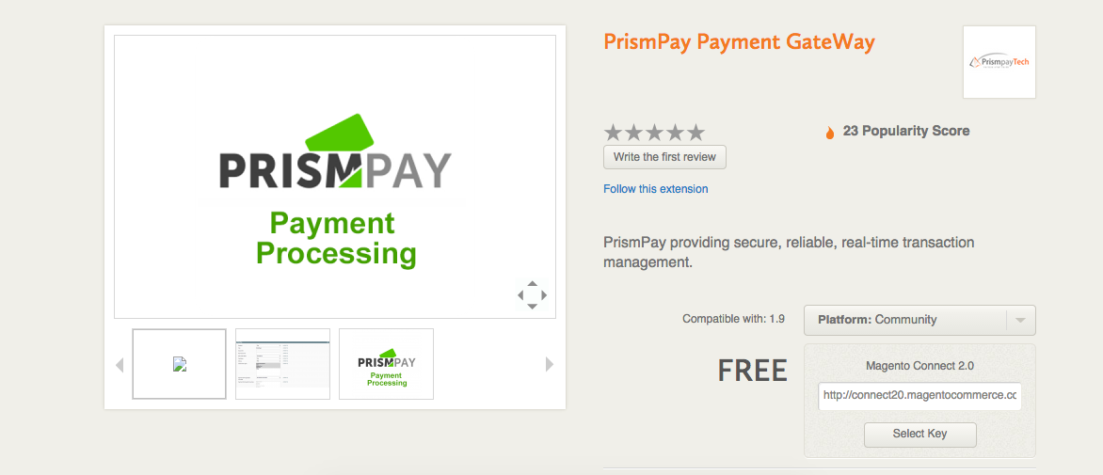

2) Log-in with your Magento Admin panel.
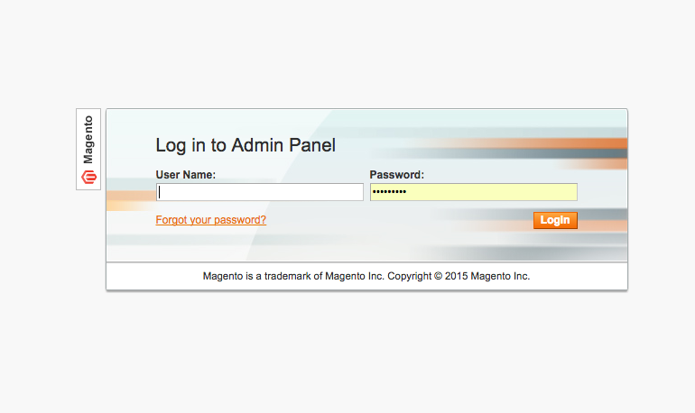

3) Click "System" at the Top menu then “Magento Connect”-> “Magento Connect Manager”.
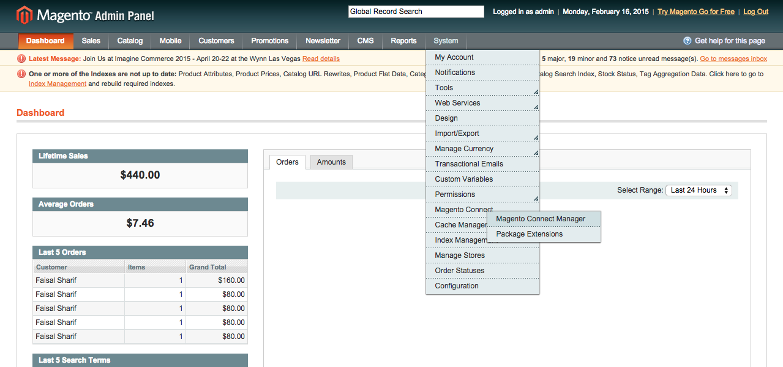

4) Now Next Screen in Magento Connect Manager Login Page , Now Please login it again with same Magento Admin Panel Credentials
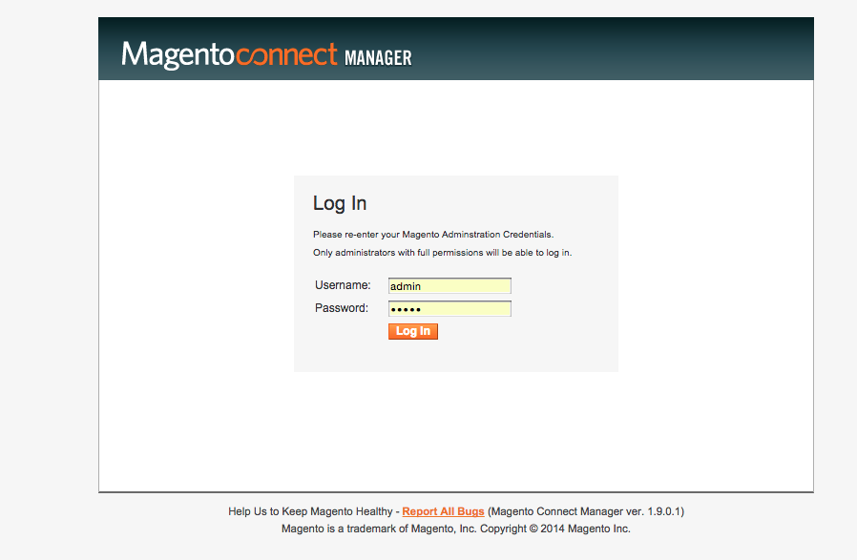
5) Now Paste Copied “Key” and click install button and then click Proceed button.
After success please click on “Return to Admin” link
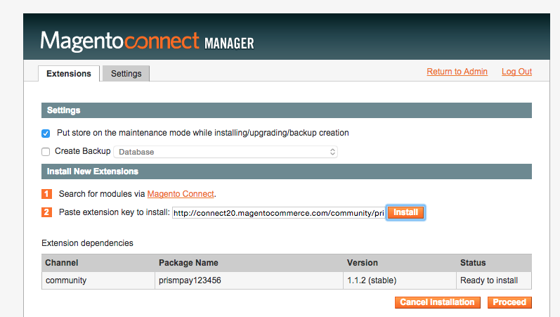

6) For Module Configuration click on System->Configuration-> Payment Methods
