Arastta Prismpay Plugin (Installation Guide):
1) Extract the Plugin File.
2) Copy, Paste and Replace the sub folder each by each of "Admin Folder" and "Catalog Folder" of your Arastta Cart web store.
3) Log-in with your Arastta Cart admin panel.

4) Click "Market Place->Payments" at the left menu.

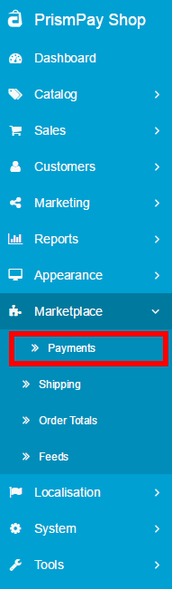

5) Browse for PrismPay and click on Green Button [Plus Sign] button to install it.
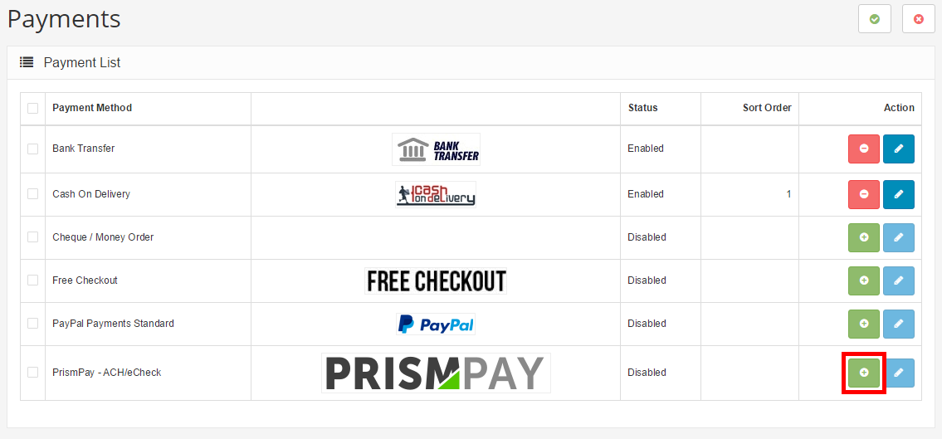

6) Click "Edit Button" to configure it.

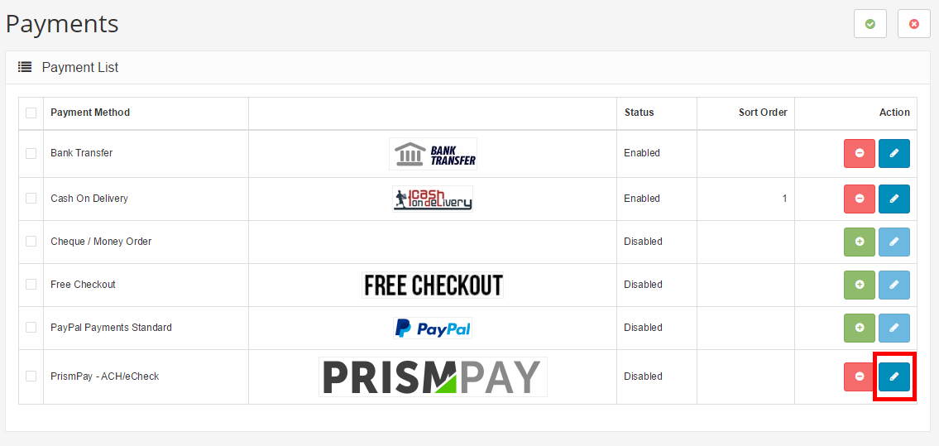

7) Fill out the configuration form and click "Save Button".
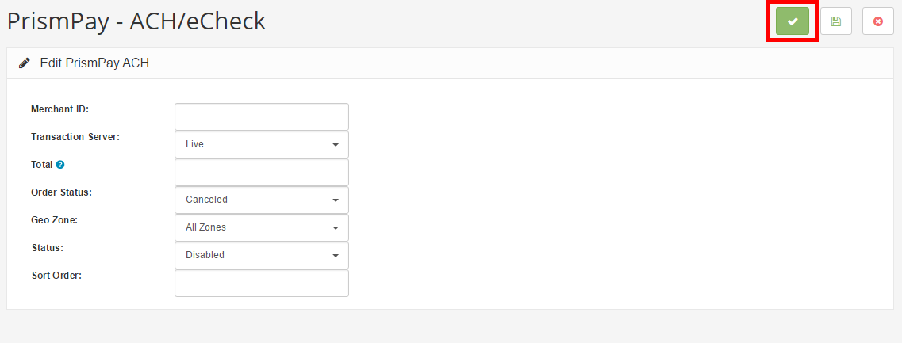

8) Configuration Form required your Prismpay Account Id, Sub Account Id (If available) and Merchant Pin (If available).
9) Set "Transaction Mode" to "Live" and get paid by your customers.

Release Notes:
Current Version: 1.0.0
1) When you install this plugins it enables E-Check processing in your Arastta Cart online store.
2) This version currently support E-check processing.

