Alegro Prismpay Plugin (Installation Guide):

Note : Before installing the Alegro cart First you have to backup of the “Upload” folder and replace it with download zip.After this Enter your settings in “config.php” under the upload folder.
1) Log-in with your alegro admin panel.by hitting this URL http://your-website-name.com/upload/prismpay/
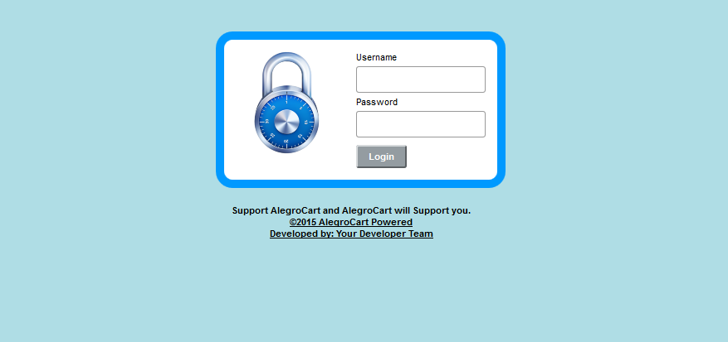
2) Click "Extention->Payment" at top of the menu. and find Prismpay & Prismpay ACH
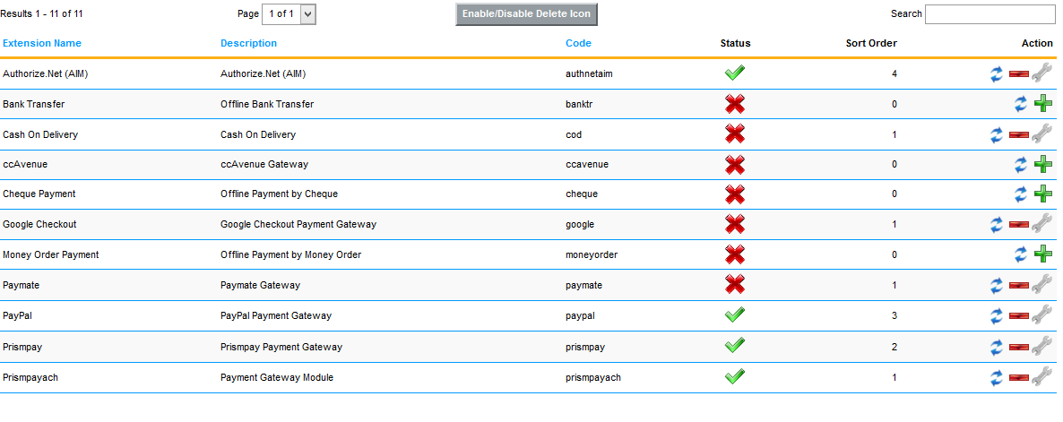

3) Install Both Plugin if you want by click on the “+” button right side of the Prismpay or PrismpayACH.
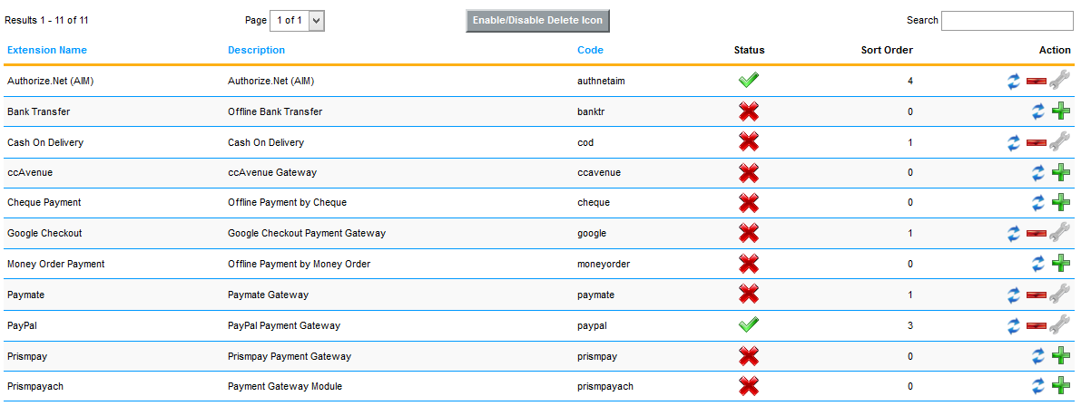
4) Enter the “AccountID , SubID and Merchant PIN “ and enable it to show on the Front hand for user shopping.
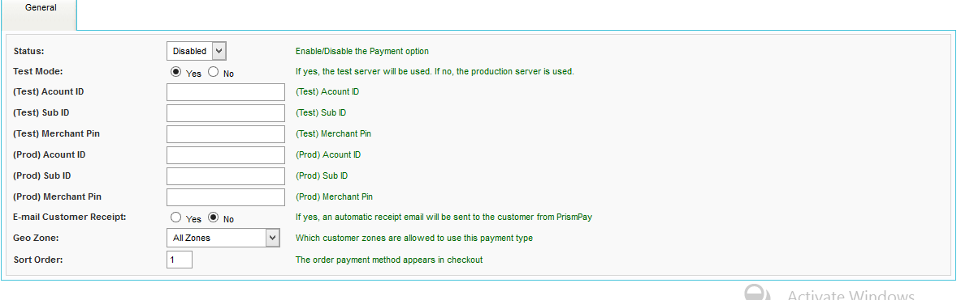

Release Notes:
Current Version: 1.1
1) When you install this plugins it enables Credit Card Processing in your website.
2) This version currently support Credit / Debit Card Processing and E-check processing.
3) This version also support Save Card Profile feature, that means users can save their profiles at the gateway and next time they can use that profile to make payments.

