WP-eCommerce Prismpay Plugin (Installation Guide):
1) Log-in with your word-press admin panel.
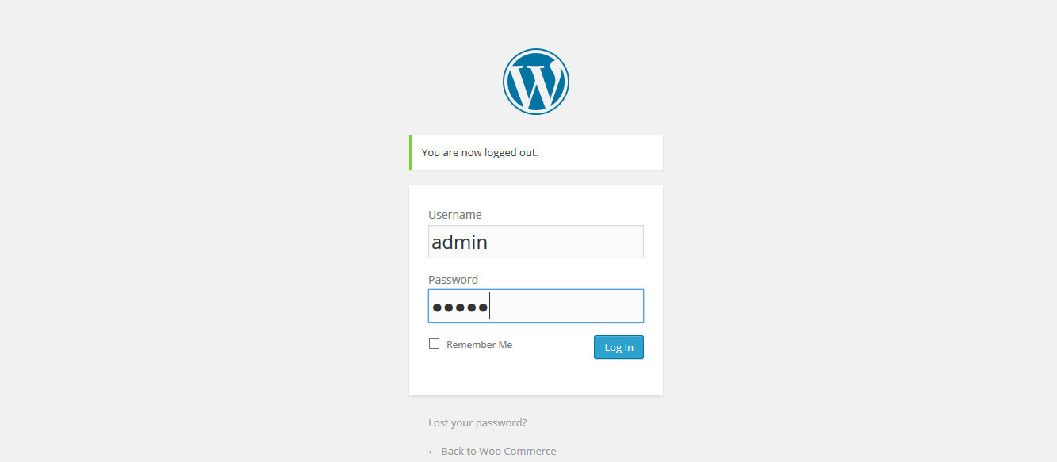
2) Click "Plugins" at the left menu.
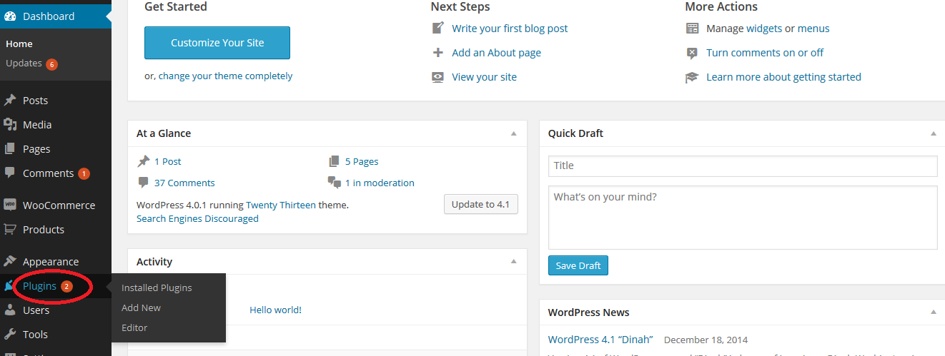

3) Click on the "Add New" button.
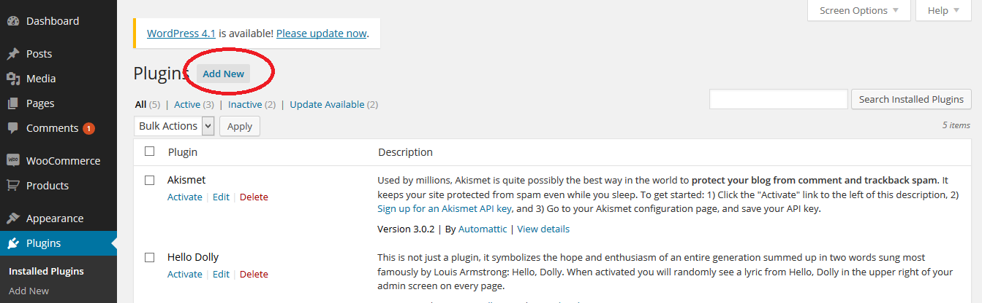
4) Click on "Upload Plugin" button.
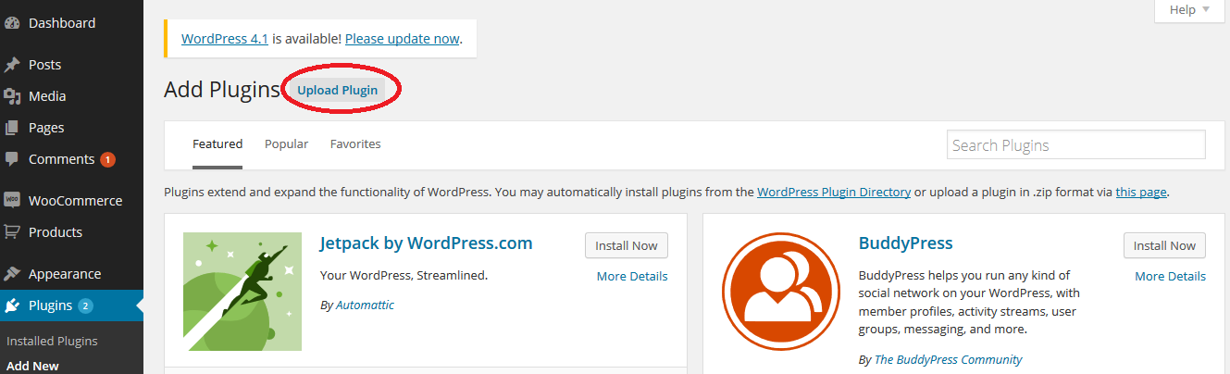
5) Browse for the Prismpay WP-eCommerce plugin to your local computer and select it.
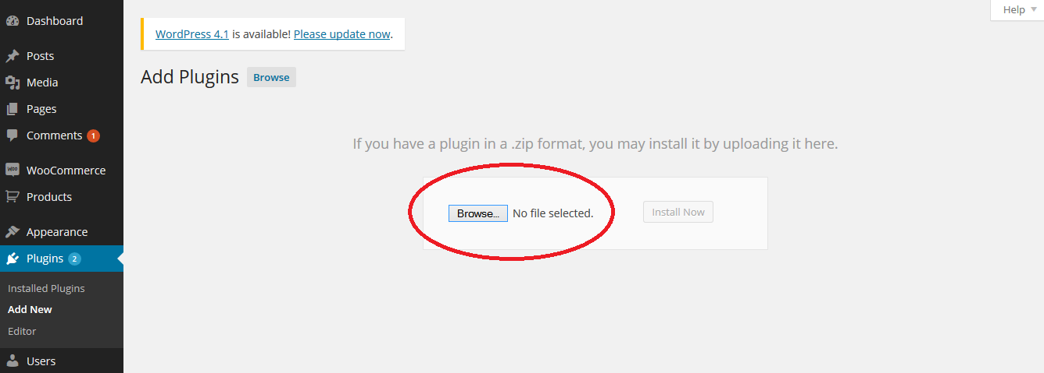

6) Click the "Install Now" button to install it. After successful installation click "Plugins" at left panel.
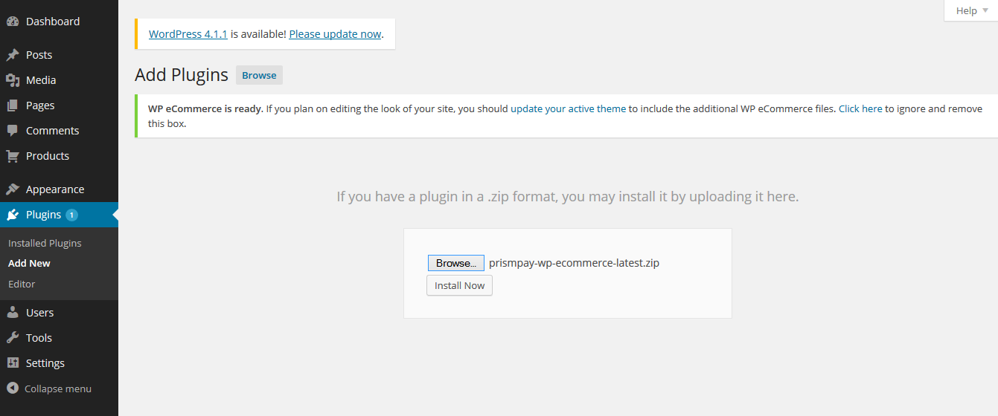
7) Prismpay WP-eCommerce plugin is now showing in the plugins installed. Now click at "Activate" link.
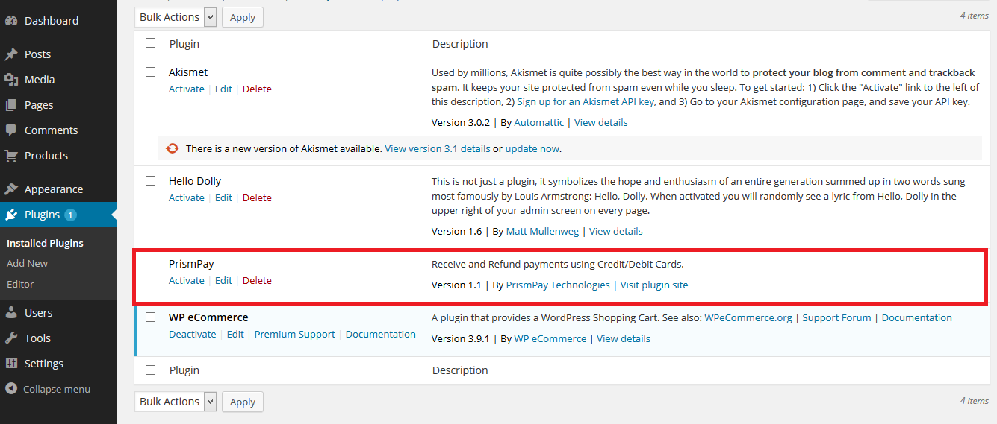

8) After successful activation of the plugin. Click "Settings => Store" at the left panel to configure the plugin.
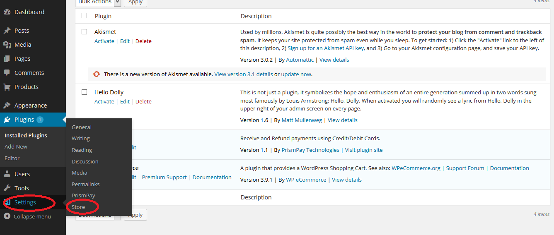
9) Click at "Payments Tab".
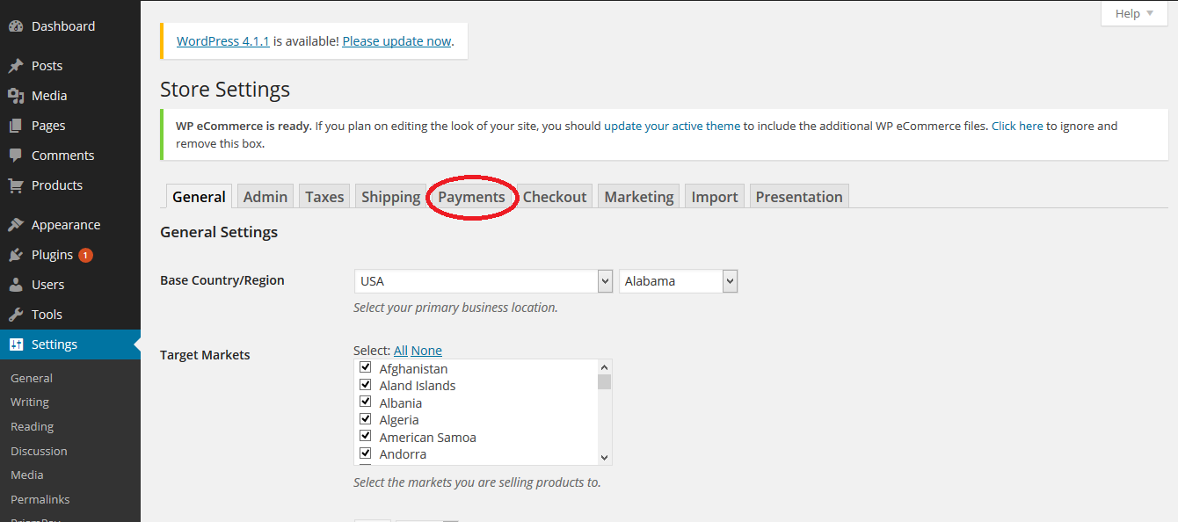

10) Prismpay is now available in the payments options for WP-eCommerce. Click "Settings" to configure it.
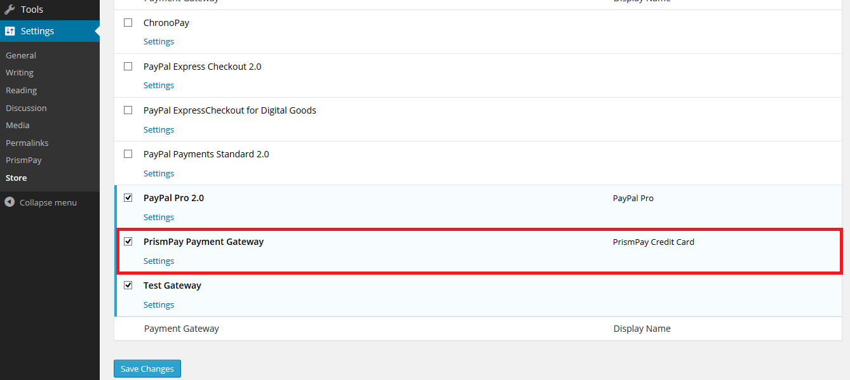
11) Configuration required your Prismpay Account Id, Sub Account Id (If available) and Merchant Pin (If available).
12) Un-Check "Test Mode Enable" to "Live Mode" and get paid by your customers.

Release Notes:
Current Version: 1.1
1) When you install this plugins it enables Credit Card Processing in your word-press WP-eCommerce website.
2) This version currently support Credit / Debit Card Processing and E-check processing.
3) This version also support Save Card Profile feature, that means users can save their profiles at the gateway and next time they can use that profile to make payments.

