TomatoCart CC Prismpay Plugin (Installation Guide):

1) Download the zip file and place the files folder wise same as zip after this Log-in with your admin panel
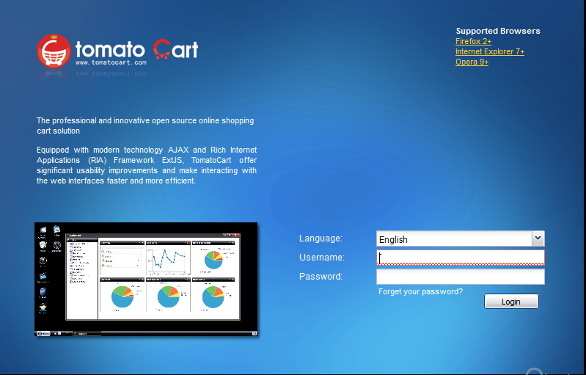
2) Click "Start->Modules->Payment Modules" and find Prismpay Credit Card
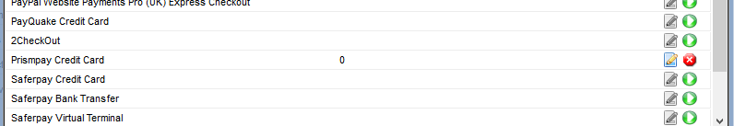

3) Install By Click on the green button after this Edit button enable and you can enter the configuration settings.
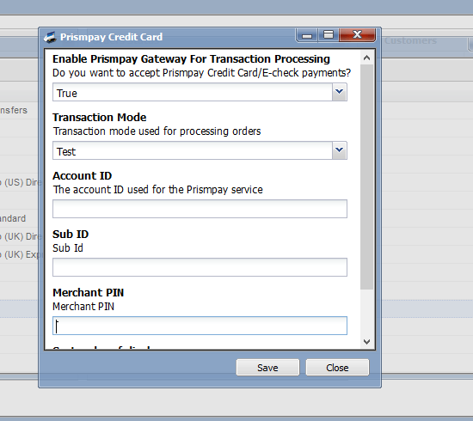
4) Enter the “AccountID , SubID and Merchant PIN “ and enable it to show on the Front hand for user shopping.

Release Notes:
Current Version: 1.1
1) When you install this plugins it enables Credit Card Processing in your website.
2) This version currently support Credit / Debit Card Processing.
3) This version also support Save Card Profile feature, that means users can save their profiles at the gateway and next time they can use that profile to make payments.

