TomatoCart E-Check Prismpay Plugin (Installation Guide):

1) Download the zip file and place the files folder wise same as zip after this Log-in with your admin panel
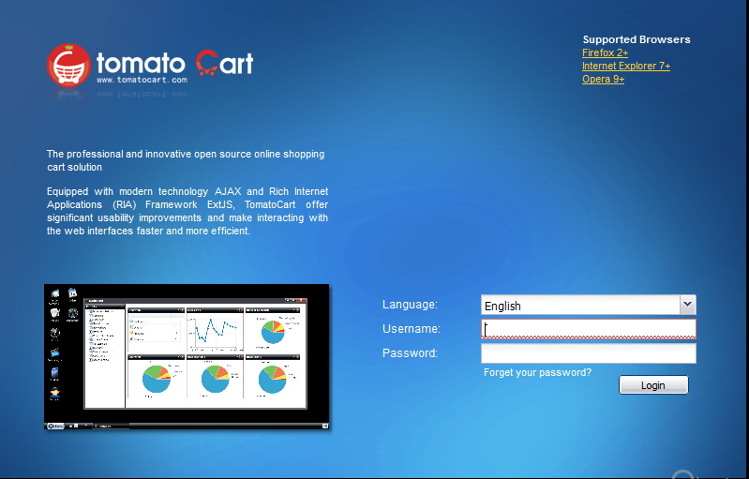
2) Click "Start->Modules->Payment Modules" and find Prismpay E-Check 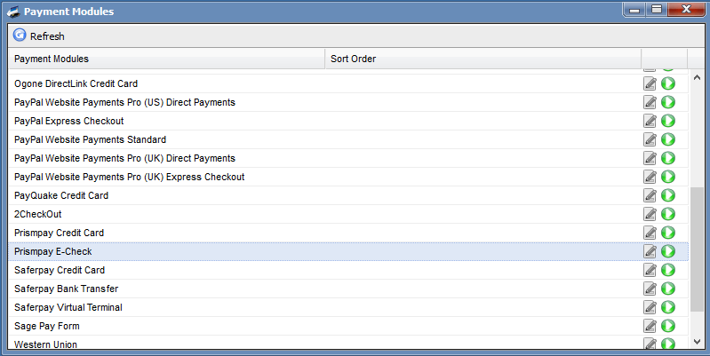

3) Install By Click on the green button after this Edit button enable and you can enter the configuration settings.
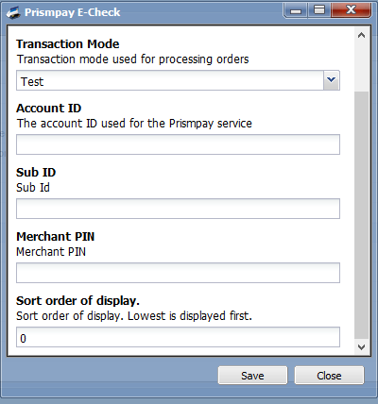
4) Enter the “Account ID , Sub ID and Merchant PIN “ and enable it to show on the Front hand for user shopping.

Release Notes:
Current Version: 1.1
1) When you install this plugins it enables E-Check Processing in your website.
2) This version currently support E-Check Processing.

